Batch: C3-3 Roll No.: 16010122221

Experiment / assignment / tutorial No. 6

Grade: AA / AB / BB / BC / CC / CD /DD

Signature of the Staff In-charge with date

TITLE: Array of Structures.

______________________________________________________________________
AIM: Program to declare an array of structure `players` having data members (name, total matches played, best bowling figure). Program should do the following operations using functions.
- Insert Minimum 5 player data in array of structure
- Sort and display this data in descending order of their best bowling figure (if wickets are same then consider less run conceded as priority) and in proper tabular form
- Delete the data for any one player.
- Search for a particular player using its name.

Expected OUTCOME of Experiment:

CO3. Illustrate the use of derived and structured datatypes such as arrays, strings, structures and unions.
CO4. Design modular programs using functions and demonstrate the concept of pointers and file handling.
_______________________________________________
Books/ Journals/ Websites referred:

- Programming in C, second edition, Pradeep Dey and Manas Ghosh, Oxford University Press.
- Programming in ANSI C, fifth edition, E Balagurusamy, Tata McGraw Hill.
- Introduction to programming and problem solving , G. Michael Schneider ,Wiley India edition.
- http://cse.iitkgp.ac.in/~rkumar/pds-vlab/

_____________________________________________________________________

Problem Definition:

Create an array of structure ‘players’ which store information about multiple players having different data members such as name, total matches played, best bowling figure.
Program should read choice from the user and perform following function:

Choice 1: Insert data in array of structure.
Choice 2: Sort and Display
Choice 3: Delete a player
Choice 4: Traverse and search a player with given name.

Algorithm:
Void main()
- Start
- Declare a structure players housing variables name[20] (char), matches (int), bowfig (int)
- Declare an array of 5 players (arr[5]) as global variable
- Ask the user to insert the data of 5 players in the array of structure
- Declare tt=1 and size=5.
- While(tt == 1)
- Declare num
- Display the menu.
- Read the value in num
- if (num==1)
- sort()
- display(size)
- Else if(num==2)
- Declare s
- Ask the user to enter the player name whose data is to be deleted
- Read the data in s
- Store the returned value of seach(s,size) in n
- If(n!=-1)
- Delete(n)
- Size=size-1
- Display that player is deleted
- Else
- Display player not found
- Else if(num==3)
- Declare name
- Ask the user to enter the player to be searched
- Read name
- Store the returned value of search(name,size) in ans
- If(ans!=-1)
- Display the player with its data at positon [ans]
- Else
- Display player not found
- Else if(num==4)
- Tt=0
- Else
- Display enter a correct Option
- End
Void sort()
- Start
- Declare i=0
- While(i<5)
- Declare max=i
- Declare j=i
- While(j<5)
- If(arr[max].bowfig<=arr[j].bowfig)
- If(arr[max].bowfig==arr[j].bowfig)
- max=maximum of(arr[max].matches and arr[j].matches)
- Else
- Max=j
- j=j+1
- Store the value of arr[i] in temp structure.
- Arr[i]=arr[j]
- Arr[j]=temp
- i=i+1
- End.
Void search(char name[20], int size)
- Start
- Declare i=0
- While(i<size)
- If( arr[i].name== name)
  - Return i
- Else
  - Return -1
- i=i+1
- End

Void display(int size)
- Start
- Print the layout.
- Declare i=0
- While(i<size)
  - Display arr[i].name, arr[i].matches, arr[i].bowfig
  - i=i+1
- End
Void delete(int n)
- Start
- While(n<5)
  - Arr[n-1]=arr[n]
  - n=n+1
- End

Implementation details:

#include<stdio.h>
#include<string.h>
struct players
{
char name[20];
int matchPlayed;
int bowFig;
};
struct players arr[5];
void sort()
{ //selection sort
for(int i=0;i<5;i++)
{
int max=i;
for(int j=i;j<5;j++)
{
if(arr[max].bowFig<=arr[j].bowFig){ //the bowling is given the priority
if(arr[max].bowFig==arr[j].bowFig) // if the bowling figure is same then
max=(arr[max].matchPlayed>arr[j].matchPlayed)?max:j; // compare matches played
else
max=j;
}
}
struct players temp=arr[i];
arr[i]=arr[max];
arr[max]=temp;
}
}
void display(int n){
printf("\nName\tMatches\tBowling fig.\n\n");
for(int i=0;i<n;i++)
printf("%s\t%d\t%d\n",arr[i].name,arr[i].matchPlayed,arr[i].bowFig);
}
int search(char name[20],int n)
{ //linear search
for(int i=0;i<n;i++)
if(strcmp(arr[i].name,name)==0)
return i;
return -1;
}
void delete(int n)
{
while(n++<5)
arr[n-1]=arr[n];
}
int main()
{
printf("Enter the Data\n"); //inseritng data
for(int i=0;i<5;i++)
{
printf("\n\nEnter Player name: ");
scanf("%s",arr[i].name);
printf("Enter %s's Matches played: ",arr[i].name);
scanf("%d",&arr[i].matchPlayed);
printf("Enter %s's Bowling Figure: ",arr[i].name);
scanf("%d",&arr[i].bowFig);
}
int tt=1,size=5; // using tt as break element. Size is set to 5
while(tt==1)
{
printf("\n\n1. Sort and Display\n");
printf("2. Delete a player\n");
printf("3. Search a player\n");
printf("4. Exit\n\n\n");
int num;
scanf("%d",&num);
switch(num){
case 1:
sort(); //sorting data
display(size);
break;
case 2:
printf("\n Enter which player you want to delete: ");
char s[10];
scanf("%s",s);
int n=search(s,size); //searching the postion of the element to be deleted
if(n!=-1){
delete(n); //deleting the searched element
--size;
printf("Player Deleted\n");} //decresing the size of array
else
printf("Player to be deleted not found!\n");
break;
case 3:
printf("\nEnter the player you want to search: ");
char name[20];
scanf("%s",name);
int ans=search(name,size);
if(ans!=-1)
printf("%s\t%d\t%d\n",arr[ans].name,arr[ans].matchPlayed,arr[ans].bowFig);
else
printf("Player Not Found!\n");
break;
case 4:
tt=0;
break;
default:
printf("Please Select a correct option\n\n");
}
}
return 0;
}

Output(s):

A.
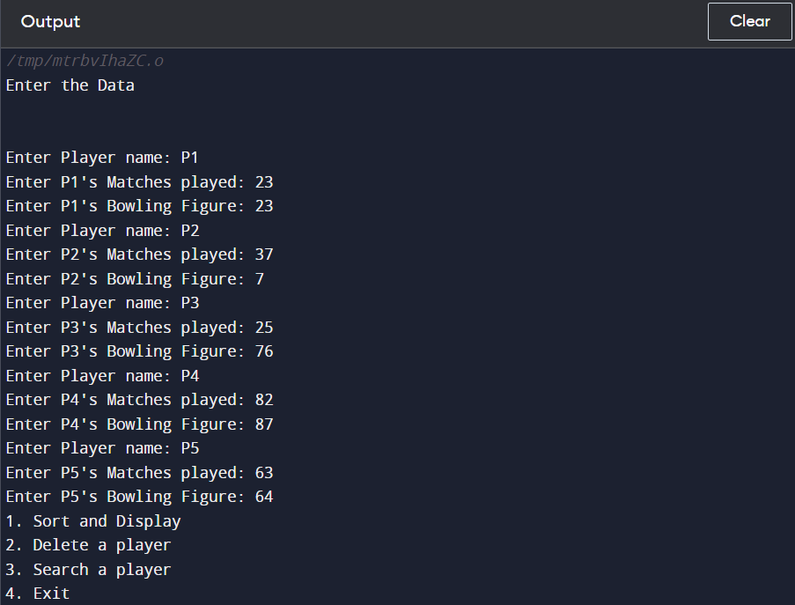

B.
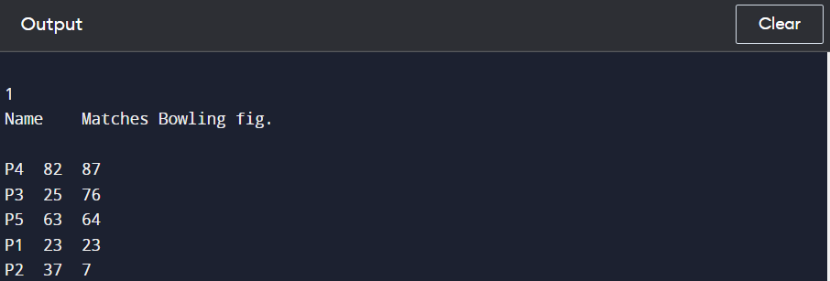
C.

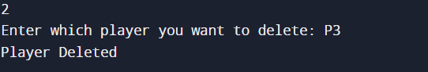

D.

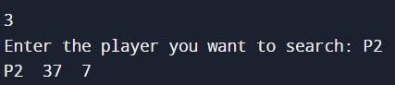

Conclusion:

Successfully executed experiment 6.
Learnt to work with structure of data, sort arrays based on different conditions, delete data, search data and to manipulate structure to our benefit.

Post Lab Descriptive Questions

- Comment on the output of the following C code.

#include <stdio.h>
struct temp
{
int a;
int b;
int c;
};
main()
{
struct temp p[] = {{1, 2, 3}, {4, 5, 6}, {7, 8, 9}};
}

Answer: No Output.

- Consider the following C code. What will be the output?

#include<stdio.h>
struct st
{
int x;
struct st next;
};

int main()
{
struct st temp;
temp.x = 10;
temp.next = temp;
printf("%d", temp.next.x);
return 0;
}

(A) Compiler Error
(B) 10
(C) Runtime Error
(D) Garbage Value

- Difference between Structure and Union.

Structure | Union
We use struct keyword to declare a structure | We use union keyword to declare a union
The size of the structure is greater than or equal to the sum of sizes of its variables | The size of the union is equal to the size of the greatest variable in the union
Each variable of a structure has a unique memory location | Memory location is shared by the variables if the union
All members can be accessed at a time | Only one member can be accessed at a time

Date: _____________ Signature of faculty in-charge

